BMHS Cross Country

2025 Centipede Run

Meet Director: Dennis Keaveney
- Email: dennis.keaveney@nbed.nb.ca
- Phone: (902)324-1937
Date: Friday, September 26th
Location: Centennial Park, 811 St. George Blvd (Races will begin at the Flood Plain next to the bridge)
Times:
- Registration: 4:15-4:30pm
- Walk Through: 4:30-5:00pm
- Junior Racers Warm-Up: 5:00-5:15pm
- Junior Race (Grade 9-10), 5:15pm
- Senior Race (Grade 11-12), 6:00pm
Distances: Juniors will run two, 2-km loops (4000m). Seniors will run two 2.5km loops (5000m). Athletes will be led by bicycle. Please see the course track below!
Registration: Registration for this event is FREE. Please send a list of athletes who are participating from your school to dennis.keaveney@nbed.ca by Thursday, September 25th at 12:00pm.
Timing: All athletes will receive their time and position. This will be emailed to all coaches following the completion of the event.

4 Km Route Map (Start at Green Marker, 2 Laps).
Finish at Red Marker.
Carte d’itinéraire de 4 km (départ au marqueur vert, 2 tours):
Terminez au marqueur rouge:
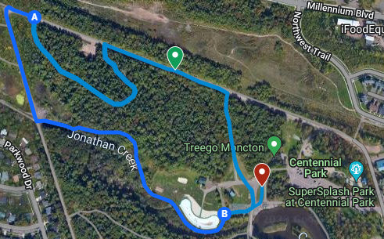

5 Km Route Map (2 laps) / 5 Km plan de route (2 tours)
(Commencez au marqueur vert).
Terminez au marqueur rouge.
